**535/1**

**PHYSICS**

**PAPER 1**

**21/4 hours**

NAME:……………………………………………………………………… Stream:……………

**SEETA HIGH SCHOOL**

**UCE PRE-REGISTRATION EXAMINATION 2016**

**535/1 PHYSICS**

**Paper 1**

**2 hour 15 minutes**

**Instructions:**

* The paper consists of two sections, A and B. Attempt ***All*** questions in section A and B.
* Section A contains 40 objective type questions. You are required to write a letter A, B, C or D against each question in the box on the right hand side.
* Section B has got 10 structured questions. Answers to this section are to be written in the spaces provided on the question paper.
* Mathematical tables, slide rules and silent non-programmable electronic scientific calculators may be used.

*Assume where necessary*

*Acceleration due to gravity, g = 10 m s – 2*

*Density of mercury= 13600kgm-3*

*Density of water = 1gcm-3 or 1000kgm-3*

***SECTION A***

1. Perfume sprayed at one corner of a room spreads to the entire room due to
2. Brownian motion. C. Diffusion.
3. Surface tension. D. Osmosis.
4. Which pair includes a vector quantity and a scalar quantity?
5. Displacement; acceleration
6. Force; kinetic energy
7. Power; speed
8. Work; potential energy.
9. A tennis ball of mass 100g is struck by a tennis racket and the velocity of the ball is changed as shown.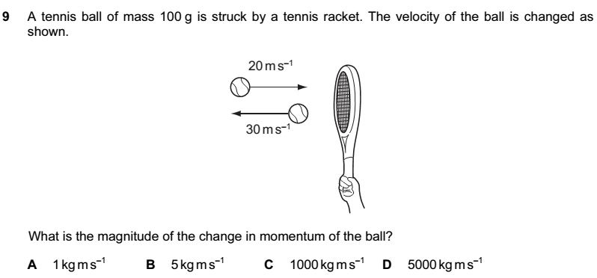

What is the magnitude of the change in momentum of the ball?

1. 1kgms-1 B. 5kgms-1 C. 1000kgms-1 D. 5000kgms-1
2. The diagram shows a parallel combination of three resistors. If the total resistance of the combination is 3Ω, what is the resistance of X?

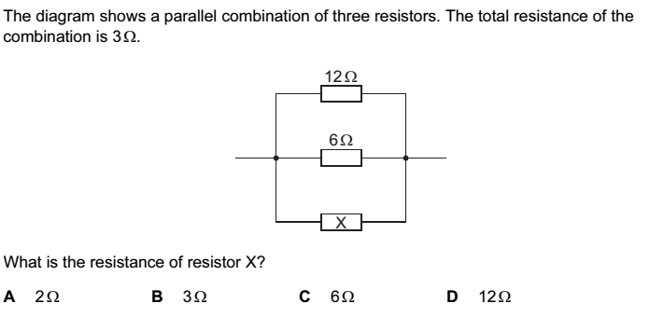



1. A translucent white plastic bottle has a green printing on it. An electric lamp with red glass is suspended inside the bottle and switched on, in a darkened room. The green printing on the bottle will appear to be;
2. Black B. Blue C. Magenta D. Red
3. A radioactive element Y of mass 64g decays to 4g in 96 days. Find the half life of Y in days.
4. 24 B. 48 C. 32 D. 12
5. A magnetic material is said to be magnetized only if
6. Another magnet attracts it.
7. Another magnet repels it.
8. It has no effect on another magnet.
9. It points in the east-west direction when freely suspended.
10. The pressure difference between the bottom and the top of a column of mercury is 100000Pa. What is the height of the column?

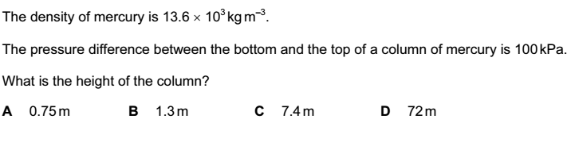

1. When a person steps forward from rest, one foot pushes backwards on the ground and the ground pushes the foot forward. This is an application of
2. Newton’s first law of motion.
3. Newton’s second law of motion.
4. Newton’s third law of motion.
5. Law of inertia.
6. Which characteristic describes an image formed by a vertical plane mirror?
7. Real and inverted
8. Virtual and not inverted
9. Real and larger than the object
10. Virtual and smaller than the object.
11. The diagram illustrates part of the electromagnetic spectrum.

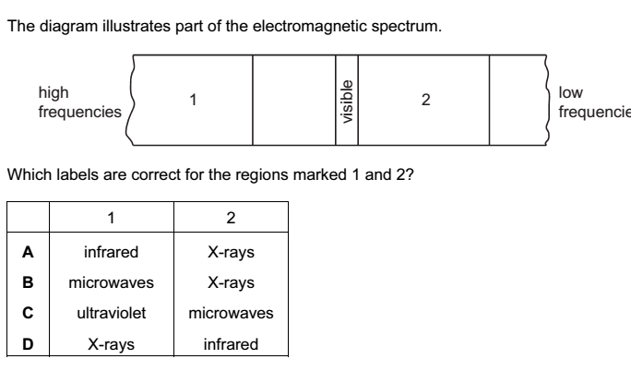

Which labels are correct for the regions marked 1 and 2?

|  |  |  |
| --- | --- | --- |
|  | 1 | 2 |
| A  B  C  D | Infrared  Microwaves  Ultraviolet  x-rays | x-rays  x-rays  microwaves  infrared |

1. A centimeter scale is fixed to an unmarked mercury-in glass thermometer. What is the reading of the thermometer?

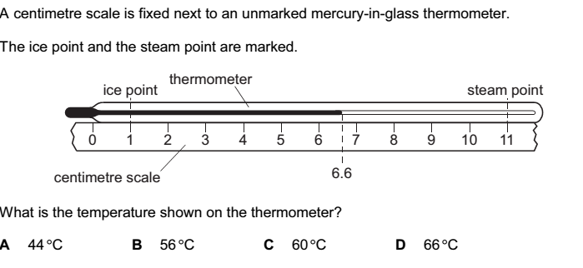



1. The source of electrons in a simple cell is
2. Dilute sulphuric acid C. Zinc plate
3. Copper plate D. Potassium chloride.
4. An oil drop of volume 10-3cm3 forms a patch on water. If the area of the patch is 0.785cm2 and it is one molecule thick, what is the size of the molecule?

A. 4.06 x 10-4cm B. 7.85 x 10-3cm

C. 9.53 x 10-4cm D. 1.27 x 10-3cm

1. Two boys S and T have masses 20kg and 30kg respectively. They climb a vertical distance of 4m in 20 seconds and 30 seconds respectively. Which one of the following statements is true about S and T?
2. The power of S is more than that of T.
3. The power of T is more than that of S.
4. The power of S is equal to that of T.
5. The work done of S is greater than that of T.
6. Which nuclides have the same number of neutron in the nucleus?

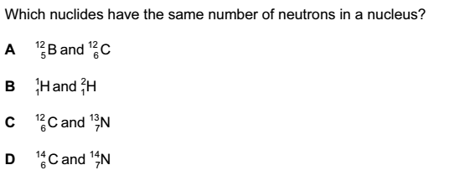

1. A ray of light moving from air meets the face of a glass block at an angle of 300 as shown below. Given that the refractive index of glass is 1.5, what is the angle of refraction, r, inside the glass?
2. 190  B. 200 C. 350 D. 400

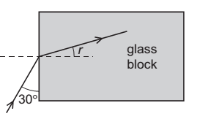

1. Which of the following are both ***third class*** levers?
2. Pair of pliers, sea saw
3. Pair of tongs, spade.
4. Wheel barrow, Nutcrackers
5. Table knife, sea saw.
6. Which of the following are brittle substances?
7. Steel, chalk, plastic and glass
8. Glass, chalk, concrete and steel
9. Dry clay, glass, glass, chalk and concrete
10. Dry clay, steel, chalk and wood.
11. A crane lifts a weight of 1000N through a vertical height of 30m. It uses 60000J of energy. What is the efficiency of the crane?
12. 20% B. 30% C. 50% D. 200%
13. Which one of the following radiations causes the body temperature to rise?
14. Infrared. B. Ultra violet. C. Gamma rays. D. X-rays.
15. Umeme charges Shs.600 per unit of electric energy consumed. What is the total cost of operating four light bulbs at 100W each for five hours?
16. Shs. 286.7 B. Shs. 1200 C. Shs. 7500 D. Shs. 2400
17. To charge an isolated metal sphere by induction, the following four processes are required.

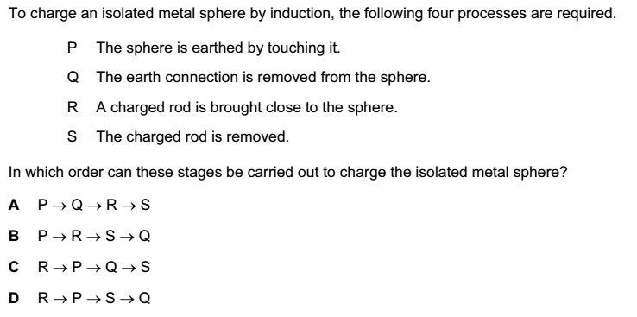

In which order can these stages be carried out to charge the isolated metal sphere?



1. What affects the stability of an object?
2. Only its weight.
3. Only its weight and its base area.
4. Only its base area and location of its centre of mass.
5. Only its location of its centre of mass.
6. A wave of frequency 13000Hz travels 1300m in 4.0 seconds. What is the wave length of the wave?
7. 0.025m B. 0.40m C. 2.5m D. 40m
8. The centre of the sun produces large amounts of energy. What is the source of this energy?
9. Chemical reaction.
10. Nuclear fission.
11. Nuclear fusion.
12. Radioactive decay.
13. 200cm3 of alcohol of density 0.8gcm-3 is mixed with 500g of water. What is the density of the mixture in gcm-3?
14. 0.80 B. 0.94 C. 1.06 D. 2.05
15. Parabolic mirrors are preferred to be used as driving mirrors in a car head lamp because they
16. Give a wide field of view.
17. Reduce the effect of spherical aberration.
18. Form upright images.
19. Form a wide parallel beam of light.
20. The diagram shows a velocity-time graph for a car.

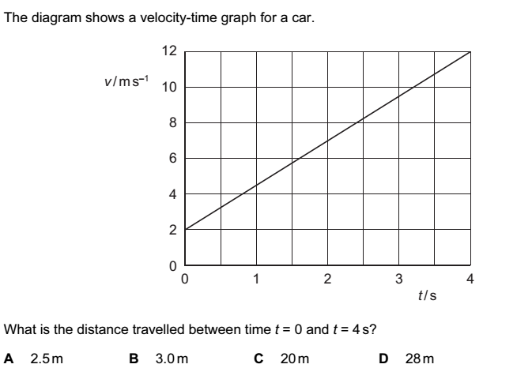

What is the distance travelled between time t=0 and t=4s?

1. 2.5m B. 3.0m C. 20m D. 28m
2. Which factor affects the sensitivity of the thermometer?
3. Constriction.
4. Diameter of the bore.
5. Length of the glass tube.
6. Thickness of the glass tube.
7. A uniform beam of weight 50N is 3.0m long and pivoted as shown. When a load of weight W is hung from that end, the beam is in equilibrium. What is the value of W?

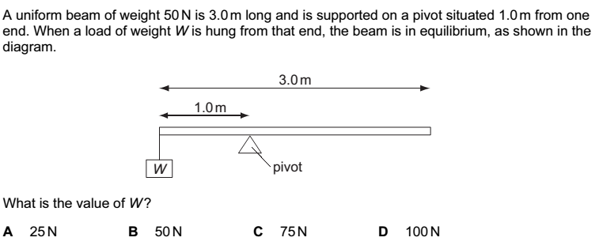

1. 25N B. 50N C. 75N D. 100N
2. In a wire supporting a load, stress is given by

A. * C. *

*B. force x area D. *

1. The colour seen in a soap film is due to,
2. Refraction C. Total internal reflection
3. Reflection D. Dispersion
4. Which statement about the speed of sound is correct?
5. Sound travels fastest in vacuum.
6. Sound travels fastest in gases.
7. Sound travels fastest in solids.
8. Sound travels fastest in liquids.
9. The diagram below shows a frozen pond with the surface of the ice slowly melting as heat is transferred from the warmer air above it.

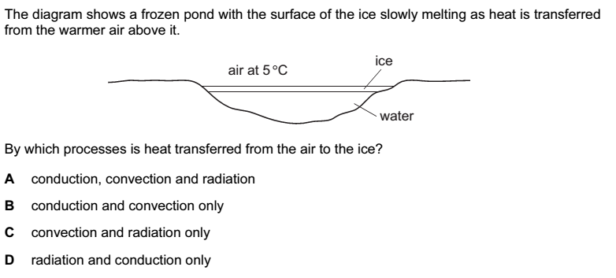



1. A metal wire has length $l$ and cross-sectional area A. what is the resistance proportional to?

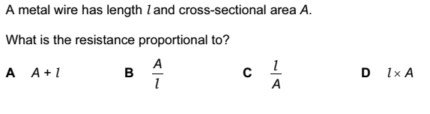

1. A pure spectrum is;
2. formed by sunlight
3. one in which colours overlap
4. one in which the colours do not overlap
5. formed by using lenses and prisms

38. Two forces of 24N and 32N act at right angle on a body of mass 2kg. Calculate the acceleration of the body in ms-2.

A. 10 B. 20 C. 40 D. 60

39. A mass of air of volume 750cm3 is heated at constant pressure from 100C to 1000C. What is the final volume of the air?

A. 7500 B. 75.0 C. 988.5 D. 859.1

Which of the following devices converts electrical energy to heat energy?

1. electric kettle C. photocell
2. battery D. thermocouple

***SECTION B(40 MARKS)***

41. (a) Define density. (1mark)

…………………………………………………………………………………………………………………………………………………………………………………………………………………………………………………………………………………………………………

(b) A builder needs to determine the density of solid cube of wood. He sets up the following experiment until the metre rule balances horizontally.

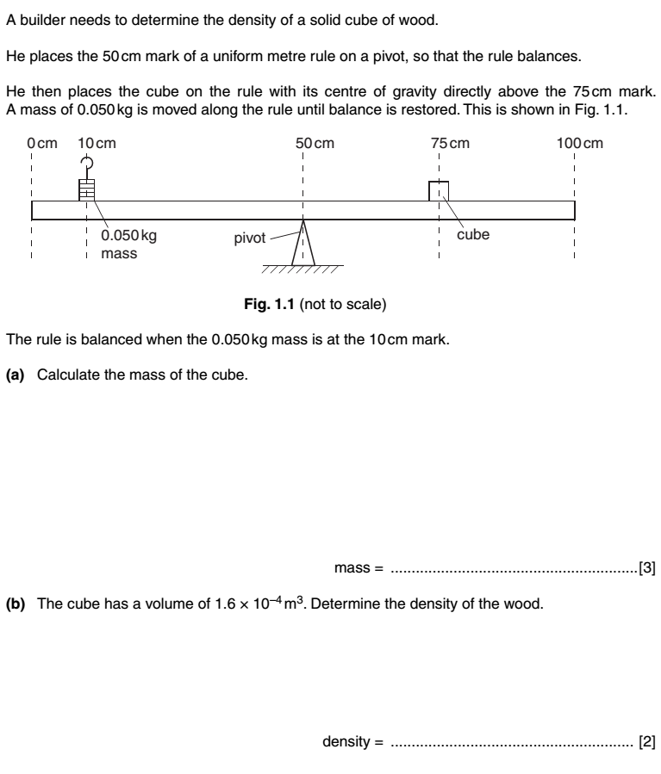

1. Calculate the mass of the cube. (1½marks)

……………………………………………………………………………………………………………………………………………………………………………………………………………………………………………………………………………………………………………………………………………………………………………………………………………………………………………………………………………………………………………………………………………………………………………………………………………………

1. The cube has a volume of 1.6×10-4m3. Determine the density of the wood. (1½marks)

……………………………………………………………………………………………………………………………………………………………………………………………………………………………………………………………………………………………………………………………………………………………………………………………………………………………………………………………...

42. The north pole N of a magnet is stroked along a metal bar in the direction shown in the figure.

A

**NN**

1. Name a metal which would become permanently magnetized by stroking in this way. …………………………………………………………………………………………………………………………………(1mark)
2. Name polarity A. (1mark)

………………………………………………………………………………………………………………………………………........

1. State two applications of permanent magnets. (2marks)

………………………………………………………………………………………………………………………………………………………………………………………………………………………………………………………………………………………………………..

43. (a) Define the term velocity ratio as applied to machines. (1mark)

………………………………………………………………………………………………………………………………………………………………………………………………………………………………………………………………………………………………

(b) A screw of pitch 2.5cm is used to raise a load of 200kg when an effort of 50N is applied to the screw arm of length 21cm. calculate;

1. Velocity ratio of the srew.(I mark)

……………………………………………………………………………………………………………………………………………………………………………………………………………………………………………………………………………………………………………………………………

1. Efficiency of the srew. (2marks)

……………………………………………………………………………………………………………………………………………………………………………………………………………………………………………………………………………………………………………………………………………………………………………………………………………………………………………………………………………………………………...

44. The radioactive decay of some nuclei gives rise to the emission of α-particles.

1. What is meant by an α-particle? (1mark)

……………………………………………………………………………………………………………………………………………………

1. A radioactive nuclide ${}_{88}^{226}X$ decays by emission of two alpha particles and two beta particles to form nuclide Y. write a balanced equation to represent this reaction. (2marks)

…………………………………………………………………………………………………………………………………………………………………………………………………………………………………………………………………………………………………………

1. State one similarity between gamma rays and beta particles. (1mark)

…………………………………………………………………………………………………………………………………………….

45. A long tube fitted with a tap is filled with water. A tuning fork is sounded above the top of the tube as water is allowed to run out of the tube as shown below.

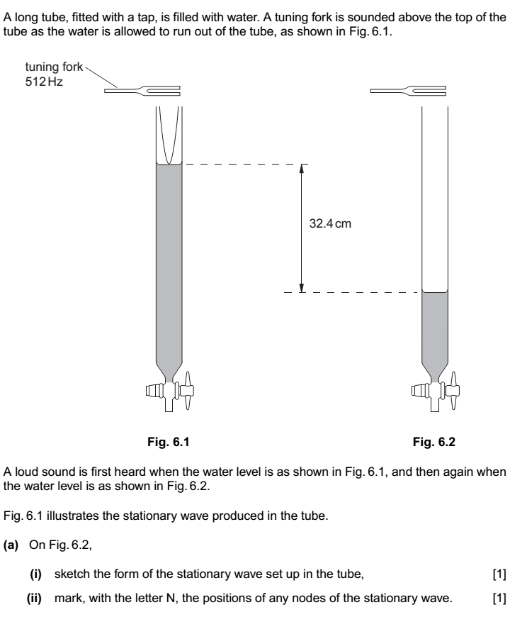

Fig.(a)

Fig.(b)

**Fig.(a) Fig.(b)**

A loud sound is first heard when the water level is as shown in fig.(a), and then again when the water level is as shown in fig.(b)

1. On fig.(b), sketch the form of the stationary wave set up in the tube.(1mark)
2. Mark, with letter N, the positions of the any nodes of the stationary wave.(½mark)
3. The frequency of the fork is 512Hz and the difference in the heights of the water level for the two positions where a loud sound is heard is 32.4cm. Calculate the speed of sound in the tube.(2½marks)

…………………………………………………………………………………………………………………………………………………………………………………………………………………………………………………………………………………………………………………………………………………………………………………………………………………………………………………………………………………………………………………………………………………………………………

46. (a) State **Boyle’s** law (1mark)

…………………………………………………………………………………………………………………………………………………………………………………………………………………………………………………………………………………...

b) The pressure of a fixed mass of a gas is 5Pa when its volume is 200cm3. Find its pressure when the volume is doubled. (3 marks)

………………………………………………………………………………………………………………………………………………………………………………………………………………………………………………………………………………………………………………………………………………………………………………………………………………………………

47. The figure below shows a nylon rod being rubbed with a woolen cloth.

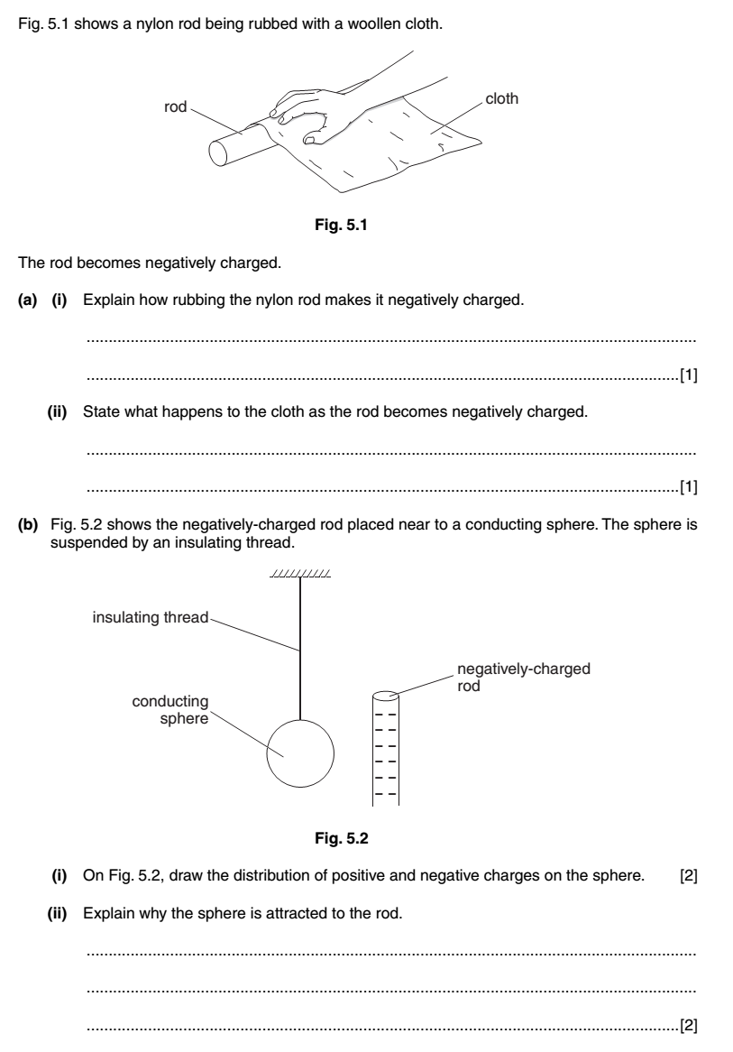

The rod becomes negatively charged.

1. (i) Explain how rubbing the nylon makes it negatively charged. (1mark)

……………………………………………………………………………………………………………………………………………………………………………………………………………………………………………………………………………………

(ii)State what happens to the cloth as the rod becomes negatively charged. (1mark)

…………………………………………………………………………………………………………………………………………

1. The average force used to slide the hand along the rod is 1.2N. In each movement the hand moves 0.080m as the rod remains stationary. Calculate the number of movements needed for 2.0J of work to be done. (2marks)

……………………………………………………………………………………………………………………………………………………………………………………………………………………………………………………………………………………………………………………………………………………………………………………………………………………………………………………………………………………………………………………………………………………………………………………………………………………

48. The figure below shows a weight of 4.0N attached to the spring. 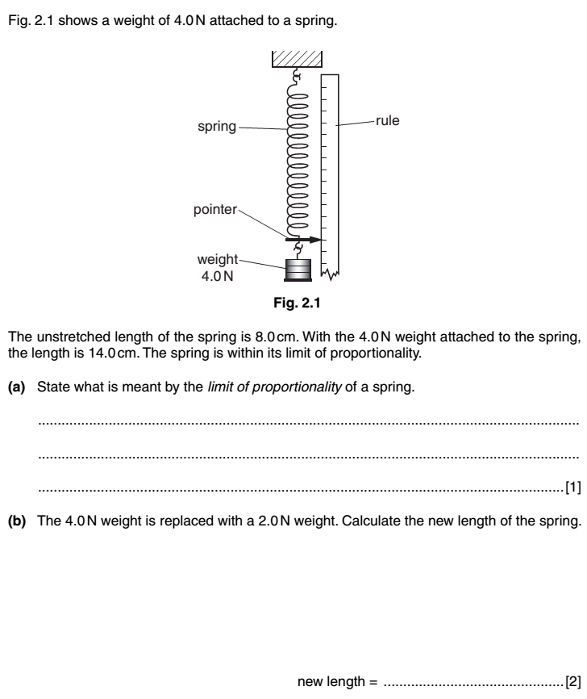

The unstretched length of the spring is 8.0cm. With the 4.0N weight attached to the spring, the length is 14.0cm. The spring is within its limit of proportionality.

1. State what is meant by limit of proportionality of the spring. (1mark)

……………………………………………………………………………………………………………………………………………………………………………………………………………………………………………………………………………………………………………………………………

1. The 4.0N weight is replaced with a 2.0N weight. Calculate the new length of the spring. (3marks)

……………………………………………………………………………………………………………………………………………………………………………………………………………………………………………………………………………………………………………………………………………………………………………………………………………………………………………………………………………………………………….

49. The student performs an experiment with a semicircular glass block and a ray of white light. The figure below shows the path taken by this light as it enters the glass at P until it hits the straight edge at Q.

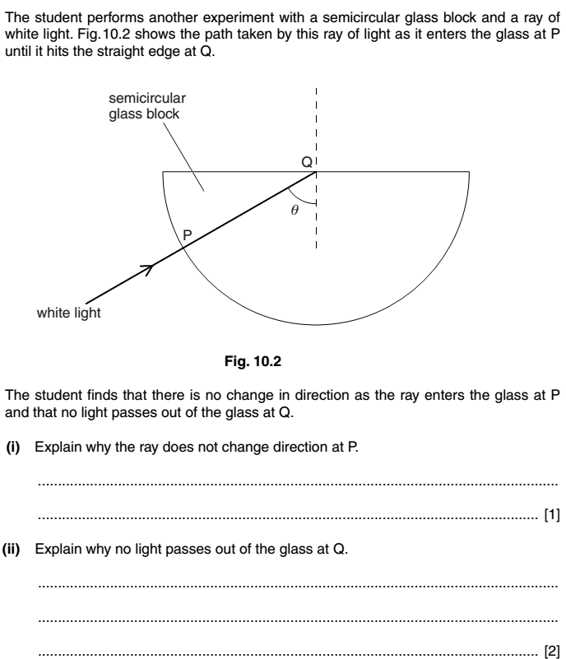

The student finds that there is no change in direction as the ray enters the glass at P and no light passes out of the glass at Q. Explain why;

1. The ray does not change direction at P. (1mark)

………………………………………………………………………………………………………………………………………………………………………………………………………………………………………………………………………………………………………………………..

1. No light passes out of the glass at Q. (1mark)

………………………………………………………………………………………………………………………………………………………………………………………………………………………………………………………………………………………………………………………..

1. Given that the critical angle for water is 48.60, calculate the refractive index of water. (2marks)

…………………………………………………………………………………………………………………………………………………………………………………………………………………………………………………………………………………………………………………………

50.(a) Define the term displacement.(1mark)

……………………………………………………………………………………………………………………………………………………………………………………………………………………………………………………………………………………………………………………………………

1. A ball is thrown vertically upward with an initial velocity of 30ms-1. Neglecting air resistance, find the maximum height reached.(2marks)

……………………………………………………………………………………………………………………………………………………………………………………………………………………………………………………………………………………………………………………………………………………………………………………………………………………………………………………………………………………………………..

1. Explain how it is possible for a car to travel a certain distance and yet has zero displacement. (1mark)

………………………………………………………………………………………………………………………………………………………………………………………………………………………………………………………………………………………………………………………………………………………………………………………………………………………………………………………………………………………………………

***\*\*END\*\****